AM310 – Instrumentation and Theory of Experiments

AM 310 Project: Design and Implementation of a Transduction System for the Measurement of a Weakly Nonlinear Mechanical Oscillator

Concepts: Dynamic sinusoidal response, Linear second order mechanical system, Damping, Stroboscope.

- Introduction

Your design project will be to plan and implement a measurement system, from transducer(s) to digitization, which will measure the response (frequency and amplitude) of a mechanical 2nd-order oscillator. The oscillator consists of two masses which can slide vertically on a rod joined by a spring (see Figure 1). The lower mass (m_{b}) is driven by a motor (through a device called a scotch yoke) to oscillate vertically at a range of user-adjustable frequencies (the RsPM of the motor can be controlled via a knob, not shown in Figure 1). The spring transmits the force from the lower mass to the upper mass (m), which causes it to move. A plate can be attached to the top mass to add mass to it and to provide a mounting surface for a transducer (use of the plate in your measurement system is optional). Since it is a second order system, the motion of the upper mass due to the lower mass will be dependent on the frequency of the motion of the lower mass. The output from your transducer/signal conditioning stage must be capable of being acquired on a digital computer. This project has long had a place in AM310 – originally it was a lab entitled “Response of a Spring-mass-damper System.” The data acquisition system used was instructive, but perhaps not optimal. It consisted of taping a pen to the upper mass, and allowing the pen to scribe lines on a moving screen as the system oscillated. The board and pen are shown in Figure 1; however that does not mean you will have to use them in your measurement system (you can, if you so choose, use the old pen-and-board data acquisition system to calibrate your measurement scheme, or to show how much better your new one is compared to the old one). By designing a computer-based data acquisition system you will able to characterize the response of the oscillator in a more systematic manner.
Disc
Motor
Scotch Yoke
Spring
Mass m
Plate
Pen
Mass
m_{b}
Vertical
Board

Rod
Figure 1: Apparatus used for studying mechanical second order system.

  - Objective

Measure the response of the spring-mass-damper system as a function of varying driving frequency. Data must be digitally acquired. To meet this objective, you must design and use a transduction scheme which will measure the oscillations of the top mass m (plus the optional plate, should you decide to use one).

  - Approach

Since time is short, 5 pre-selected transduction schemes have been developed. You are not restricted you to these 5 a priori, but if you choose to research another transduction scheme of your own, keep in mind that there is only a limited budget on which to draw to purchase new items. This project REQUIRES that you IMPLEMENT your scheme, so if it can’t be bought you’ve wasted your time. Therefore, don’t suggest using a scanning laser vibrometer, since those cost upwards of $25,000. A TOTAL price tag (transducer, electronics, other necessary stuff) of around $500.00 would be an upper bound.

We have purchased 2 setups for each of the 5 pre-selected systems. These will be assigned to the first 2 groups requesting them. At the point your group has decided to pursue a particular system, please contact the TF’s, so that they can ensure that only 2 groups are assigned any single system. If you wish, the TF’s will simply assign you a particular transducer scheme. PLEASE COMPLETE THIS STEP IN YOUR FIRST LAB PERIOD, OR BY YOUR SECOND LAB PERIOD AT THE LATEST.

In the next section, a model is presented that can be used to predict the motion of the top mass provided the motion of the bottom mass is known. Since each of you will use a different measurement system, there will be no detailed procedures in written for this project: you must devise them yourselves; however, in Section 3, a set of general procedures are outlined that should guide you to a successful conclusion of the project. The five pre-selected transduction schemes are described in Section 4. Finally, Section 5 contains questions that you must answer using the data you collected.

- Theory

Consider the system of two masses connected by a spring shown in Figure 2. A displacement of the lower mass m_{b} will cause a corresponding displacement of the upper mass m. The displacements would be equal to each other only if the motion of mass m_{b} takes place very slowly (i.e. at a low frequency). As the frequency of motion of mass m_{b} increases the displacement of mass m becomes increasingly different from that of mass m_{b}. This is because of interaction between the spring force and inertia force on the upper mass m.
Figure 2: System of coupled masses arranged to slide on a rod.
Mass m
Mass
m_{b}
As will be shown below, the equation of motion for the upper mass m can be written (From the free body diagram of m, Figure 3) as 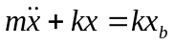,where k is the spring constant of the spring. If x_{b} (the displacement of mass m_{b}) a sinusoidal motion such as X_{b}sin(ωt) (with X_{b} a constant amplitude), then 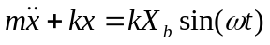would be the differential equation governing the motion of mass m as a function of the motion of the mass m_{b}.

It can be shown that the steady state solution to this equation is:

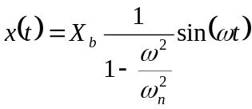 (for ω<ω_{n}) (1)

where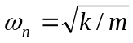is the natural frequency of the system.

It can clearly be seen that although the motion of the mass m is sinusoidal at the same frequency as mass m_{b}, the amplitude depends on both the input frequency and the natural frequency, i.e. the amplitude of the top mass not necessarily equal to the amplitude of the bottom mass.

We can take our simple mechanical system one step further so it can more accurately model real systems if we include a loss mechanism; specifically we add a damper which ideally resists motion of the mass m by offering resistance proportional to the velocity of mass m (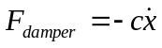).

The governing differential equation for the mass m in Figure 2 if it had an ideal damper (A mass-less plate, for example made from unobtanium) attached to it and if the motion of m_{b} is sinusoidal can be written as:

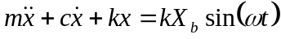 (2)

Equation 1 can be easily derived by applying Newton’s Second law to the top mass (the derivation for the case without a damper would follow similar steps). Consider a free body diagram of the top mass, here F_{s} is the force due to the spring, and F_{d} is the force due to the damper.

F_{d}
F_{s}
x
Figure 3: Freebody diagram of mass m.

where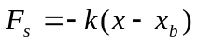, and 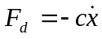, with k, x, x_{b}, c defined as they were above.
Newton’s second law states that the sum of the forces on the mass is equal to its mass times its acceleration (here recall that x has been defined as the vertical direction):

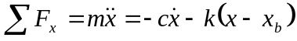
Rearranging terms gives:
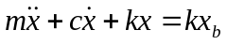
Substituting for x_{b} yields:

, which is the result we were looking for.

In order to solve this equation to find x(t) explicitly as a function of x_{b}(t), it is easiest to work with complex exponentials. Observe that since both k and X_{b} are constants the product kX_{b} is also a constant; examining the units of this product will show that it is a force. Therefore, let:

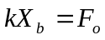
and since:
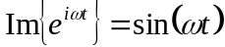
then:
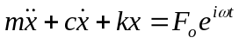

and we will look at just the imaginary part of the solution when we get it.
We assume:
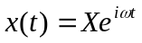

in which X is a constant, the output amplitude.

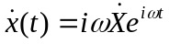

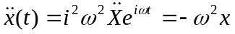
Plugging in gives:
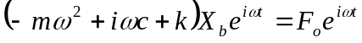

Canceling exponentials and rearranging gives:

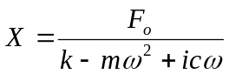

Multiply top and bottom by the complex conjugate of the denominator to get:

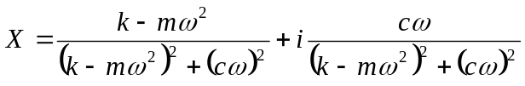

At this point, we recall that for this type of expression:

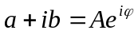
Where:

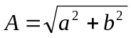
and:
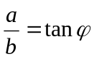
so:
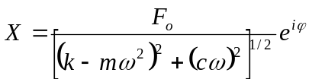

Divide top and bottom by k, and recall that kX_{b}=F_{o} or, F_{o}/k=X_{b}, then letting:

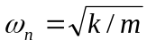,

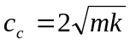,
and
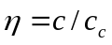
X can be written as:

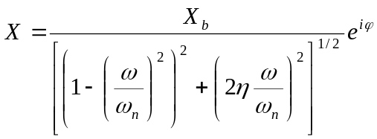
If we are interested in the ratio of input and output amplitudes, the exponentials cancel and we are left with:

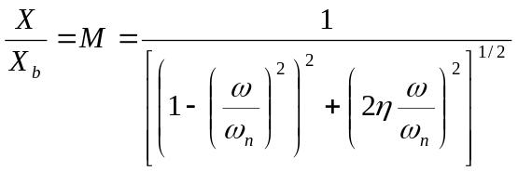

where X is the output amplitude. Also:

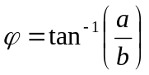
so:
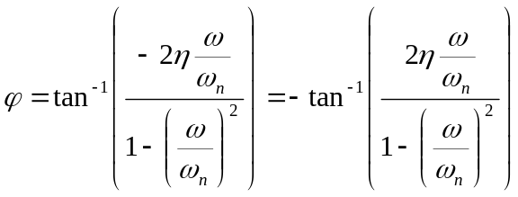

Therefore, the complete time-dependent steady-state solution is (taking the imaginary part of the complex solution):
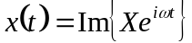

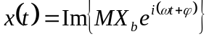

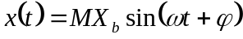

Summarizing the steady state response of the displacement of the top mass as a function of the displacement of the bottom mass we get:

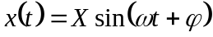
in which

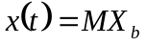 (3)

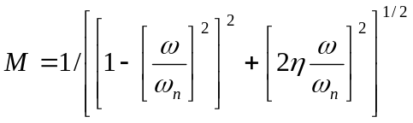 (4)

is the “amplitude magnification ratio,” “amplitude ratio,” or “magnitude ratio,” in which
, is the natural frequency
, is the damping ratio
, is the critical damping ratio
and

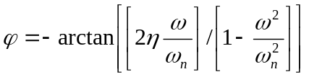, (5)

is the phase lag.

It can be seen that the motion of mass m is dependent not only on the motion of mass m_{b} but also on the system parameters ω_{n} and η. The behavior of M and φ as functions of ω/ω_{n} and η i.e., (Equations 4 and 5) are shown in Figures 4 and 5.
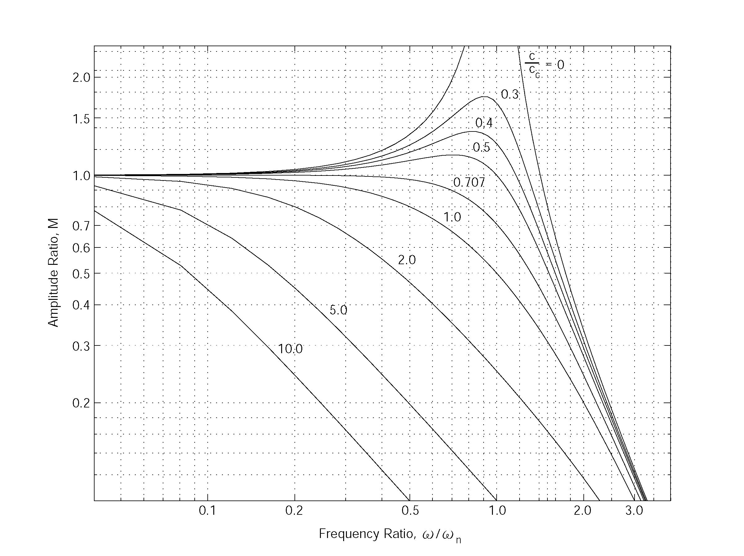Figure 4: Frequency Response of second order system for various values of c/cc
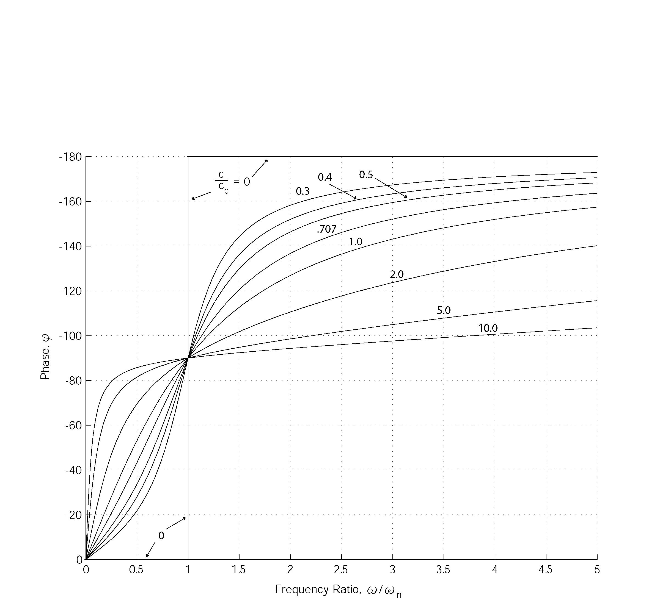Figure 5: Phase-Shift response for second-order system
Here is should be stressed that the forgoing theory was developed for a 2nd order linear oscillator. It is very difficult to assemble a truly linear 2nd order oscillator, i.e. one that does not deviate at all from linear theory: all real systems have some small amount of non-linearity inherent to them, including the system you will study. You should be aware of the fact that you may encounter measurable deviations for the linear theory developed in this section. Since the mathematics involved is beyond the scope of this course, you do no have to incorporate nonlinear terms into the model – just be sure to understand the linear model well enough so you can recognize deviations from it.

- Experimental Procedures

NOTE: SINCE THIS EXPERIMENT INVOLVES EXPOSED MOVING PARTS, THE WEARING OF SAFETY GOGGLES IS REQUIRED.

Here a set of general procedures is described. It is written in a general sense because each of your measurement systems will be different, so you will have to individually determine the best procedures to follow to complete the project.

1. Determine the spring constant of the spring used in the oscillator

2. Determine the natural frequency of the upper mass

3. Calibrate the knob of the motor so that you can know what the driving frequency is for a particular setting of the knob. You can use your measurement system to do this if it is capable of doing so, if not, use a stroboscope.

4. Measure the total linear displacement of the lower mass. This is the peak-to-peak amplitude of the input signal. The input amplitude is one half of this value.

5. Measure the dynamic response of the oscillator. Take data for both increasing and decreasing frequency. The data should be taken at enough frequencies to form a well-resolved (i.e. 4 frequency steps is not sufficient, shoot for more – around 25 if possible) set of response data that spans from below the resonance frequency, defined as 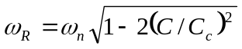 to above it. Each measurement should be made only after the system has attained a steady state (Why?). Ideally the data you report should be the average of several runs at the same frequencies so you can estimate the precision uncertainty of your measurement system. Provided your transducer can measure it, you should take data so that you can report the displacement vs time of the top mass as well as it amplitude as a function of frequency.

While measuring the dynamic response of the oscillator, you should note whether the oscillator bottoms out. If the mass does bottom out, can you use the data that you collect for that frequency? Also, note the DC offset of your signal, as you may need it for the analysis of your data.

- Description of Pre-Selected Measurement Schemes

Following is a table that contains a brief describing of each of the pre-selected measurement schemes.
PRE-SELECTED SCHEMES | Ultrasonic air-ranging transducers | Optical proximity sensor | Linear potentiomenter | Digital video imaging
Method/principles | Short tone bursts of ultrasound are emitted from a focused air transducer, which is periodically switched between send (“pulse”) and receive (”echo”) mode. Pulses are reflected from the object to be measured. By knowing the time between emission and reception of a pulse and the sound speed in air, the distance can be calculated. | Continuous, modulated broadband LED light is emitted and collected from a fiber bundle. The light emitted has a known spreading angle. The light is reflected from the object to be measured. By obtaining the reflected intensity, the distance to the object can be calculated. | A sliding contact connected to an extensible wire moves between two endpoints of a third resistive wire (or resistor) which drops an applied voltage. The voltage read from the sliding contact is some fraction of the applied voltage, and is linearly proportional to the length the extensible wire is extended. Thus, suitably calibrated, a measurement of the voltage is a measurement of the distance. | An analog video image of the object to be measured is obtained and digitized. By detecting image features corresponding to the object of interest (for example, an edge transition corresponding to the plate edge), the position of the image feature within successive images can be calculated. The distance of the object can then be calculated
Quantity measured | Acoustic pressure pulse, in phase | Broadband continuous light intensity | DC Voltage proportional to resistance of changing length of wire. | Number of pixels between qualifying image features
Output of transducer/embedded electronics | Analog AC Voltage pulse (toneburst) with center frequency at transducer resonance frequency, variable start time, pulse length, and repetition frequency. | Analog DC current (4-20 mA) proportional to received light intensity. | DC voltage. | Software-dependent:  Entire image, or ASCII resultant of image measurement – all outputs digital.
Spatial Resolution | Dependent on product specs and implementation: potentially 100 microns | Dependent on product specs and implementation: potentially 1 mm | Dependent on product specs and implementation: potentially 100 microns | Dependent on product specs and implementation: potentially 1 mm
Temporal resolution | Dependent on repetition frequency: 3 Hz to 25 Hz, or user supplied? | Potentially 100 Hz | Dependent on acquisition, unknown lifetime issues | Implementation dependent: up to 25 Hz
Range of motion detected | Dependent on transducer selected: 8 cm to 30 ft | Model dependent: 24 – 48 inches nominal | 0.5 to 25 in | Lens, lighting dependent: 0 – 1 ft nominal

PRE-SELECTED SCHEMES | Accelerometers
Method/principles | An internal oscillatory mechanism is mounted to the walls of container, which is then mounted to the device in question. The acceleration of the base of the container is the quantity sensed.
Quantity measured | Acceleration
Output of transducer/embedded electronics | Analog DC Voltage signal proportional to the acceleration.
Spatial Resolution | Indirect, proportional to acceleration.
Temporal resolution | DC – 100 Hz
Range of motion detected | Unlimited (except by cable length), but acceleration is limited by bandwidth

As you can see from this partial listing of features, there are potential advantages and disadvantages to each of the pre-selected transducers. Each group will be asked to choose either one of the transducer types from the table, or implement another scheme/transducer not listed in the table. For example, you might (but probably won’t) elect to measure the Doppler-shifted acoustic signal, by either reflecting a source from the plate, or mounting a source to the plate. You would then need to get a source (and receiver), function generator, and probably analog electronics to detect the Doppler shift – FM demodulation is the usual way. The resulting analog signal could then be digitized.

Computer Acquisition

For the first three transducers, the output is an analog voltage or current signal. This signal needs to be suitably conditioned and then digitized. Each of the 6 PC’s in the lab is equipped with a multifunction A/D board installed in one of the PCI slots. These boards have 12 bit resolution and maximum 100 kSample/s sampling rate (one board has a higher maximum rate). For any group using the video imaging system, the output is already digital over an Ethernet line, and available to you for analysis. The PC’s have LabView installed to perform software control of the A/D conversion, plus instrument control and data analysis. You will have to learn some LabView in order to do the acquisition (with the exception of the video imaging option – with that option, you will have to learn the image acquisition and analysis software supplied with the cameras.)

- Results

1. Plot the experimental amplitude ratio X/X_{b} as a function of ω/ω_{n}. Be sure to indicate which line for increasing frequency and which line is for decreasing frequency. As a guide the plot should look something like the theoretical curves in Figure 4.

2. Note that , and that the critical damping coefficient is 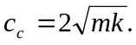 At ω=ω_{n}, the amplitude ratio M=1/[η]=1/[2(c/c_{c})]. Since the critical damping coefficient can be determined and the amplitude at the natural frequency was measured, the experimental damping coefficient can be determined and you can compare your experimental results to theory (i.e. the theoretical curves corresponding to your experimentally determined damping ratio). Do so by showing and clearly labeling the theoretical as well as the experimental curves on a single plot. Does the model correspond to the data collected while increasing the frequency, or to the data collected while decreasing the frequency?

3. If you are able to measure it, report the phase shift of the upper mass relative to the bottom mass as a function of frequency. If you cannot measure it be sure to note its qualitative behavior. Discuss the behavior of the phase in terms of the theoretical model.

- Further Reading

Beer, Ferdinand P. and E. Russell Johnston, Jr. Verctor Mechanics for Engineers (Statics & Dynamics). New York: McGraw-Hill Ryerson, 1981. Chapter 19

Dally, James W., William F. Riley, and Kenneth G. McConnell. Instrumentation for
Engineering Measurements. 2nd ed. John Wiley & Sons, 1992. Pgs: 55-60.

Beckwith, Thomas G., N. Lewis Buck, and Roy D. Marangoni. Mechanical
Measurements. Reading, Massachusetts: Addison-Wesley, 1982. Pgs: 68-72.

Holman, Jack P. Experimental Methods for Engineers New York: McGraw-Hill, 1971.
Pgs: 19-25.

Figliola, Richard S. and Donald E. Beasley. Theory and Design for Mechanical
Measurements. 2nd ed. New York: Wiley, 1995. Pgs: 81-90.

- Who to blame:

Written by Dr. Bala Bharadvaj (Sept. 1984)
Revised by Dr. Bala Bharadvaj (Jan. 1985)
Revised by Dy. Mort Isaacson (Feb., May & Sept. 1985)
Revised by Dr. Mort Isaacson and Mr. Mike D’Angelo (Jan. 1987)
Revised by Dr. Mort Isaacson and Mr. Greg Richardson (Sept. 1987)
Revised by Dr. Mort Isaacson (1992, 1996, Jan. 1997)
Revised by C. Thomas and Dr. R.G. Holt (Aug. 2003)

